SARANG. N. R

# PROFILE

MCA student.

I consider my self a responsible and orderly person. I am looking foward for my first work experience. a challenging career opportunity in an organization where I can enhance my knowledge and technical skills

# CONTACT ME

7012296803

[godseye146@gmail.com](mailto:godseye146@gmail.com)

Njattuvetty House

puthenpeedika post valamuck

Code:-680642

Thrissur(dist)Kerala

# EDUCATION

## MASTER OF COMPUTER APPLICATION

*Kerala technical*

*university(2021/23)pursuing*

## BACHELOR OF COMPUTER APPLICATION

*Bharathiyar university*

*(CGPA in percantage:73.93%*

## HIGHER SECONDARY(BIO SCIENCE)

*Govt. Nalandha kizhupullikara 73.5%*

## SSLC

*Govt. SNGSHS KARAMUCK 80%*

# COMPUTER SKILLS

Html Php

Python Mysql

# LANGUAGE

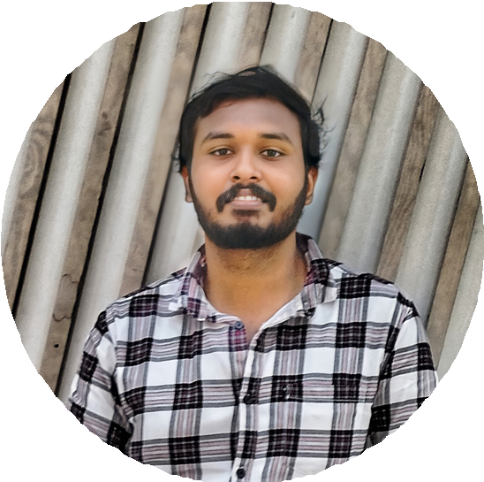

English

Malayalam

# ACADEMIC PROJECT IN BCA

Blood Bank Management System 'BBMS' through php